**Week-1 Assessment**

**Steps to Follow:**

Step 1: Create a New Project in Power BI by clicking on the option

‘BLANK REPORT’. Now in Power BI Desktop Window, to get data,

Click on the icon in the Home says ‘Get Data’.

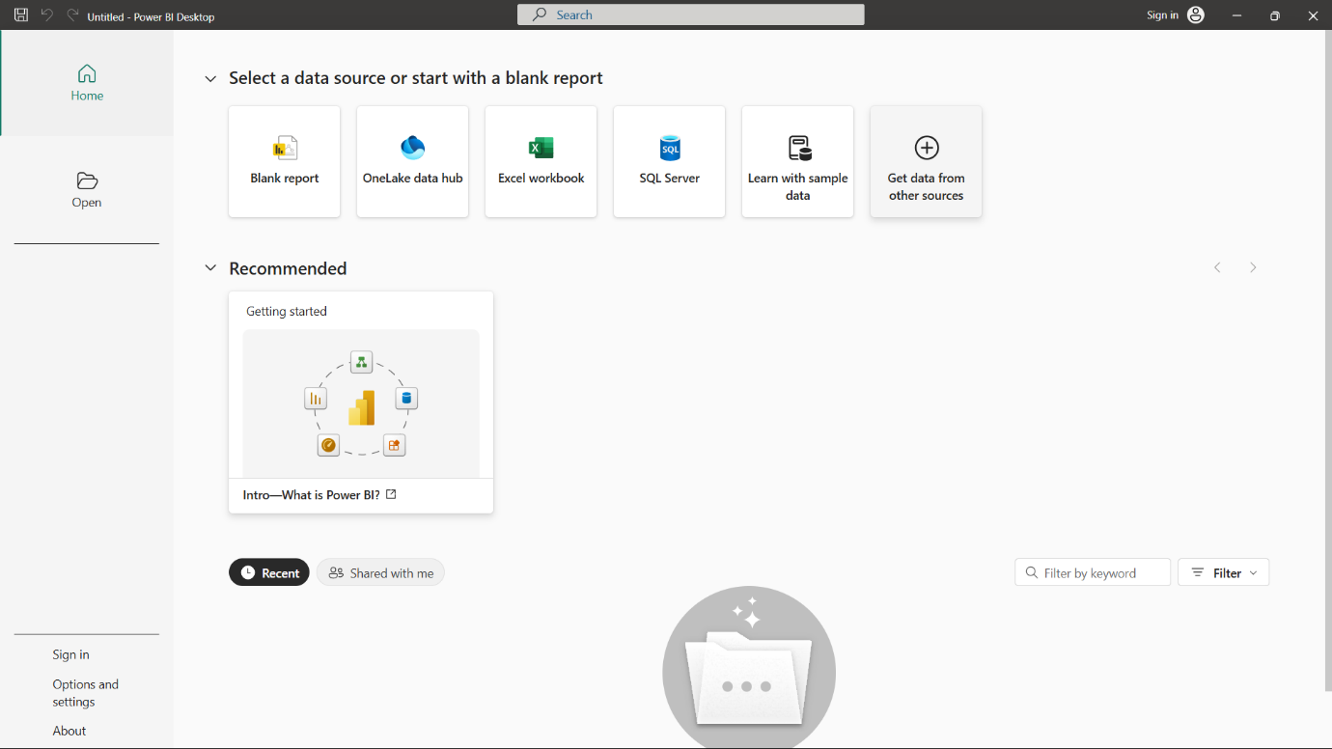 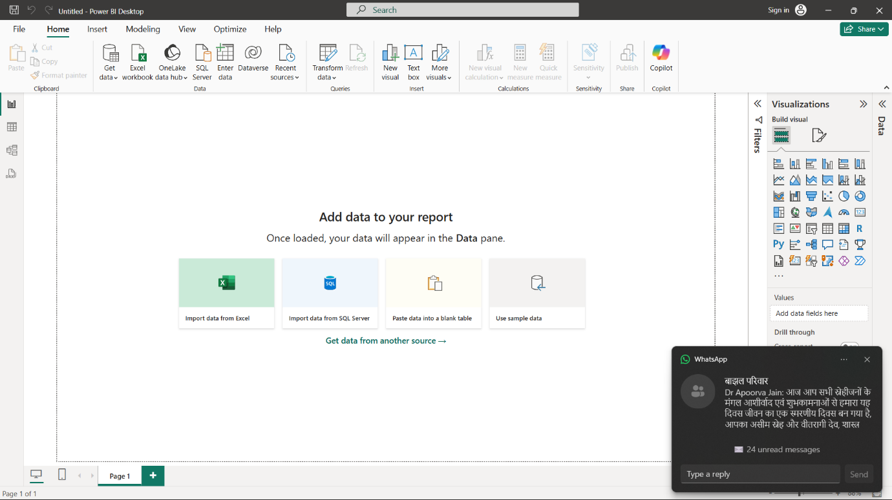

Step 2: As we have already given a static data CSV file, we will selct the

option of ‘Text/CSV’ from dropdown column.

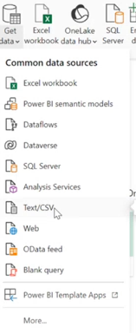

Choose the required data i.e. Sustainable Supply Chain Performance.

Step 3: The Overview of your selected data will appear, with two options

which are LOAD and TRANSFORM DATA.

**LOAD:** When you know that your data is clean and do not have any

unnecessary column in your dataset, then you can directly

upload the data in Power BI.

**TRANSFORM DATA:** If the dataset contains some unnecessary thing

and needed to be transformed, then choose the

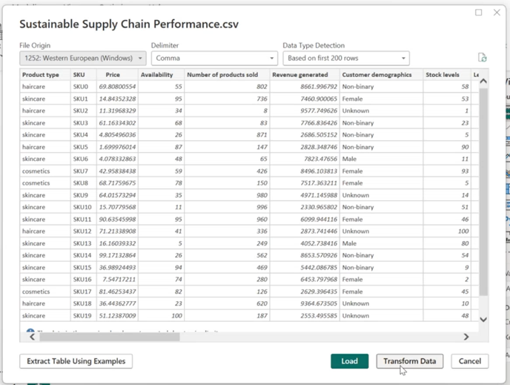 option of Transform data.

Step 4: Now to increase efficiency and readability of data, we can create

multiple separate tables from a single table with their relevant Data

column.

To create these tables, Right click on the table in Queries section and

choose the option of Duplicate table. Again, right click on duplicated

table and Rename it with the New Name.

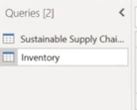

Step 5: Now, from new table, remove those columns which are not required in

that new table.

To do so, select the column, right click on it and choose option Remove

to remove it.

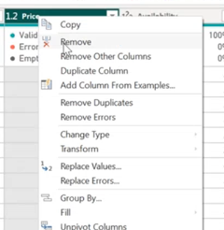

Step 6: Continue doing this until you got the required collection of separated

columns.

Here, I am going to create multiple columns given are provided by

organisation.

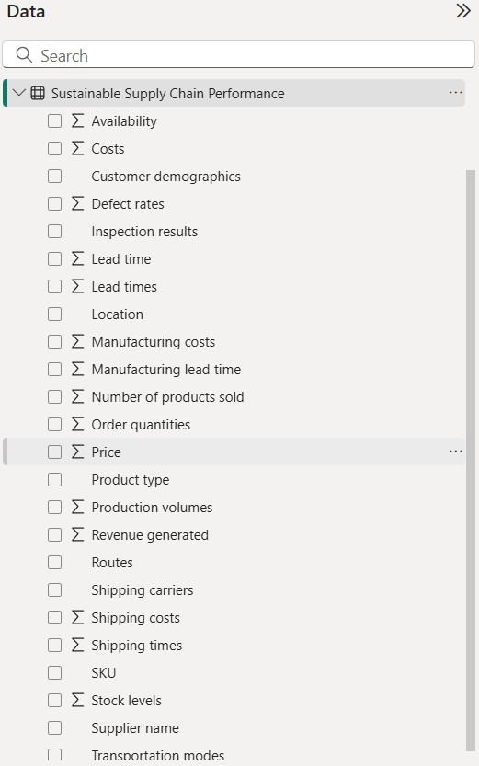 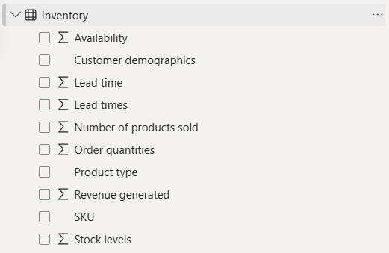

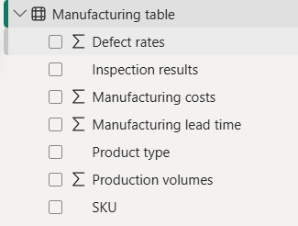 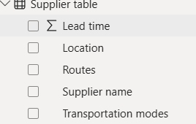

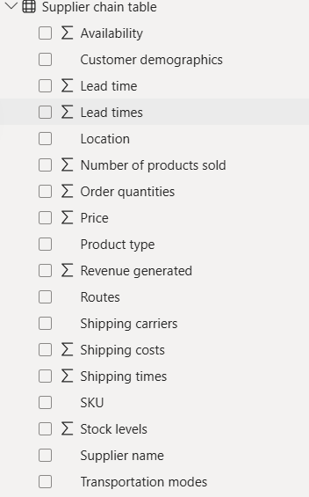

Step 7: Hence, to commit the changes, choose Close and Apply option

in Home tab and then save the file.